

**Name:** O G Ragavi  **Slot**: L31+32

**Reg No:** 20BCE1988  **Date: 27.09.2022**

**Lab Ex:** 9

—------------------------------------------------------------------------------------

**Initial set-up:**

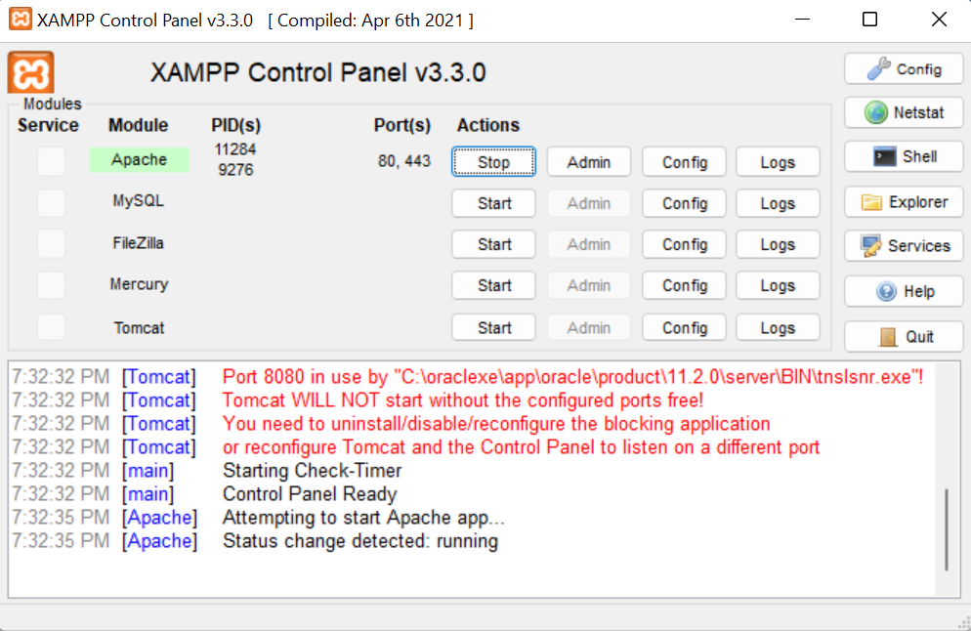

**Q1)**

**Code:**

<html>

<head>

<title>Lab 9-a</title>

</head>

<body>

<form method="POST" action="">

<label for=" eid">Enter the employee id:</label>

<input type="text" name="eid">

<br><br>

<label for="name">Enter the name of the employee</label>

<input type="text" name="name">

<br><br>

<label for="qual">Enter the qualification of the employee</label>

<input type="text" name="qual">

<br><br>

<label for="des">Enter the designation of the employee</label>

<input type="text" name="des">

<br><br>

<input type="submit" value="submit" name="submit">

<br><br>

<input type="submit" value="Display" name="display">

</form>

<?php

if(isset($_POST['submit']))

{

$eid=$_POST['eid'];

$name=$_POST['name'];

$qual=$_POST['qual'];

$des=$_POST['des'];

$handle=fopen('./lab9a1.txt','a+');

$a="\nEmployee id is: ".$eid;

$b="\nEmployee name is: ".$name;

$c="\nEmployee qualification is: ".$qual;

$d="\nEmployee designation is: ".$des;

fwrite($handle,$a);

fwrite($handle,$b);

fwrite($handle,$c);

fwrite($handle,$d);

fclose($handle);

}

if(isset($_POST['display']))

{

$handle1=fopen('lab9a1.txt','r');

while(!feof($handle1))

{

echo(fgets($handle1,1024));

echo('<br/>');

}

copy('./lab9a1.txt','./lab9a2.txt');

fclose($handle1);

}

?>

</body>

</html>

**Output:**

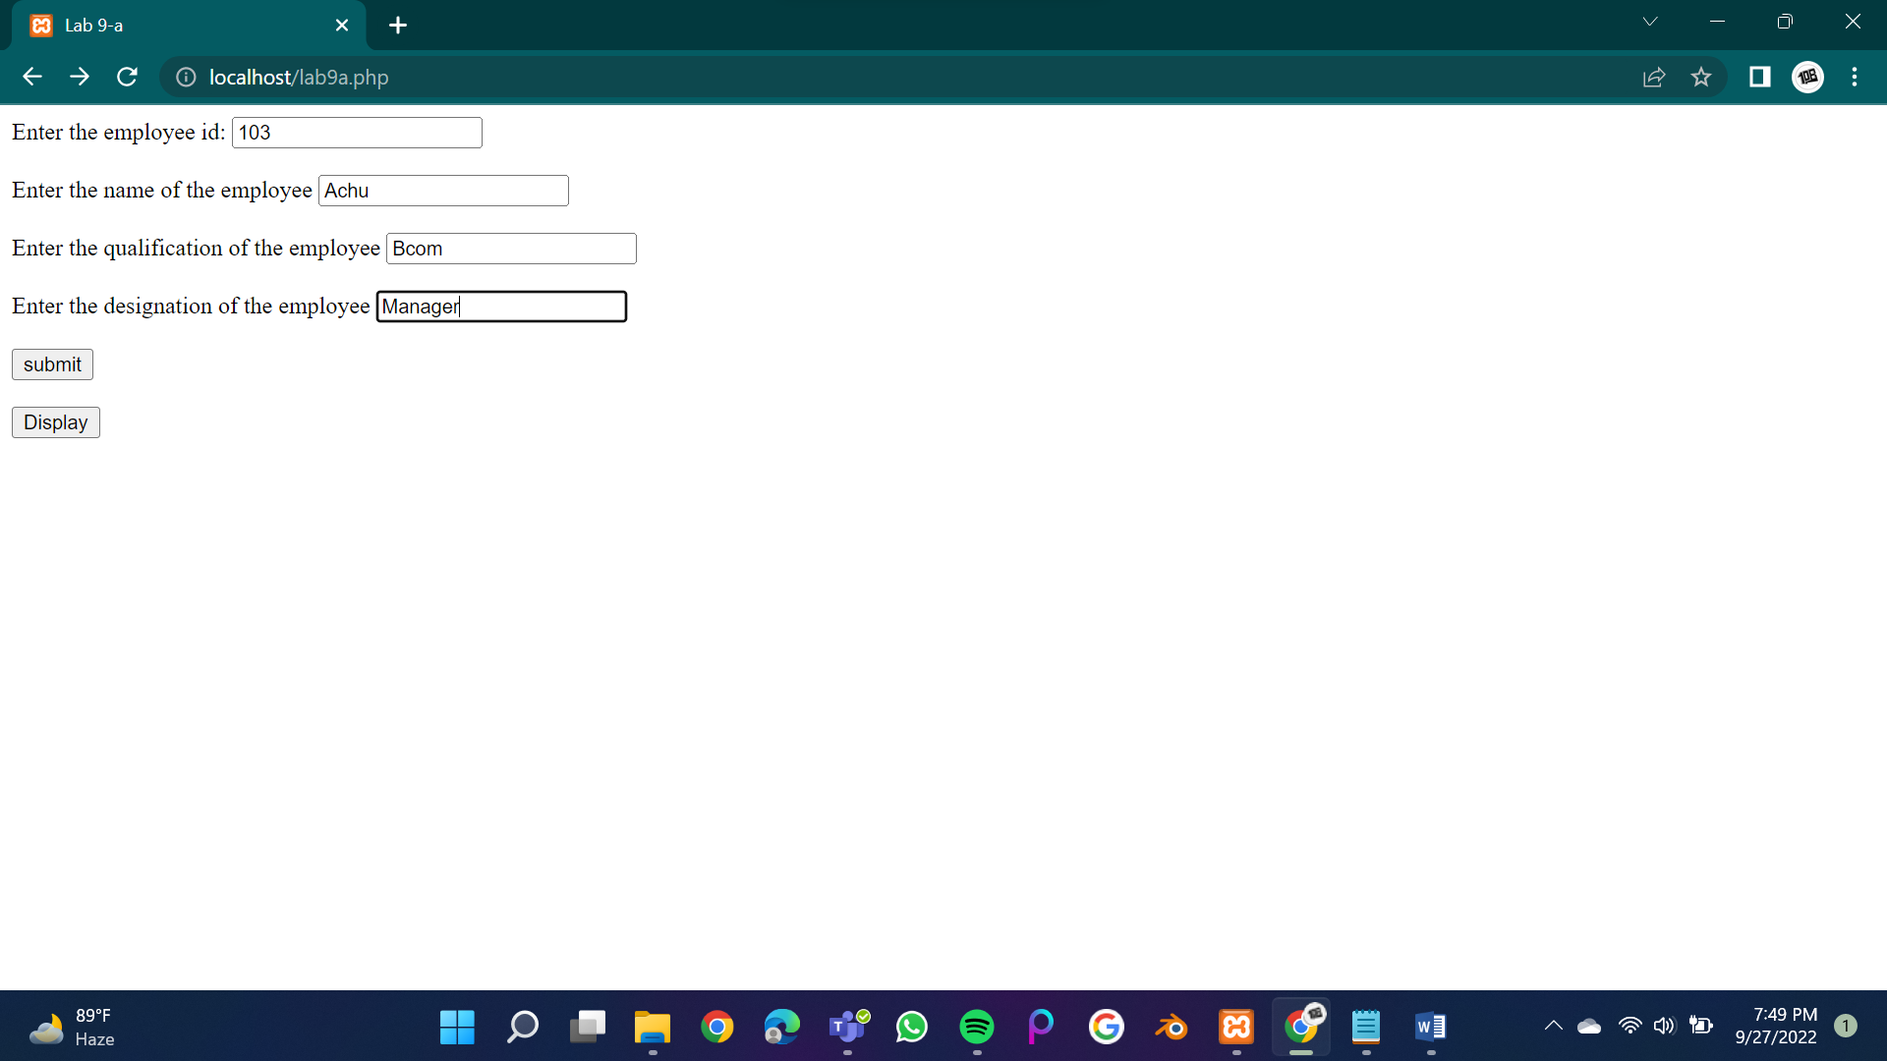

After submitting:

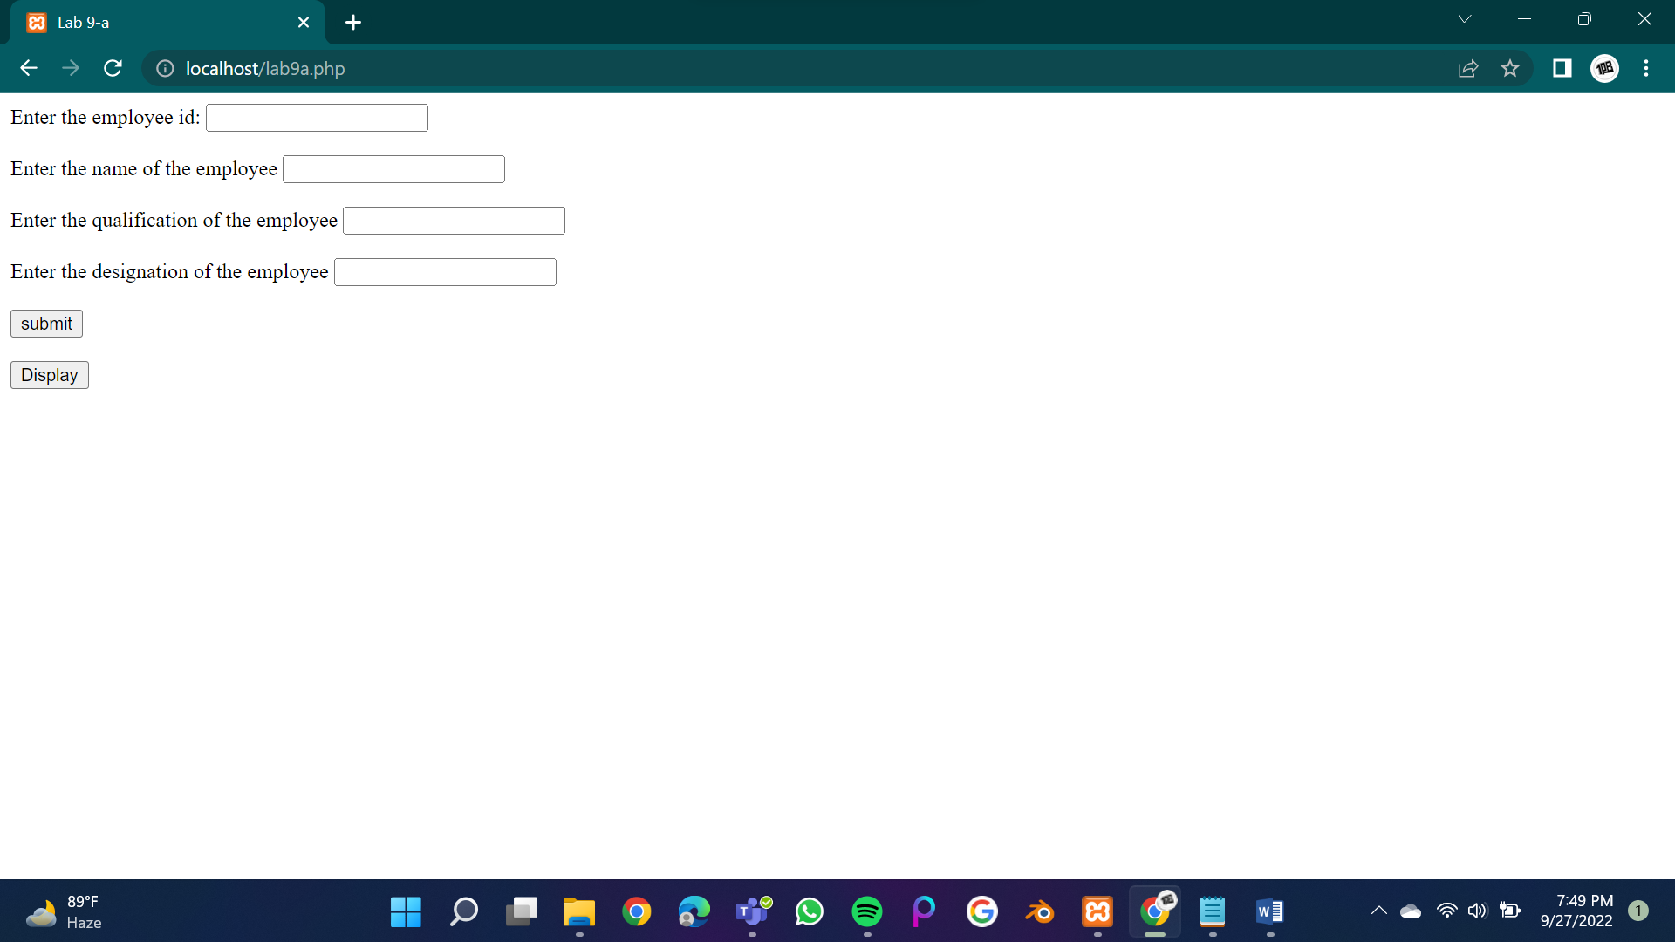

After clicking on to ‘display’:

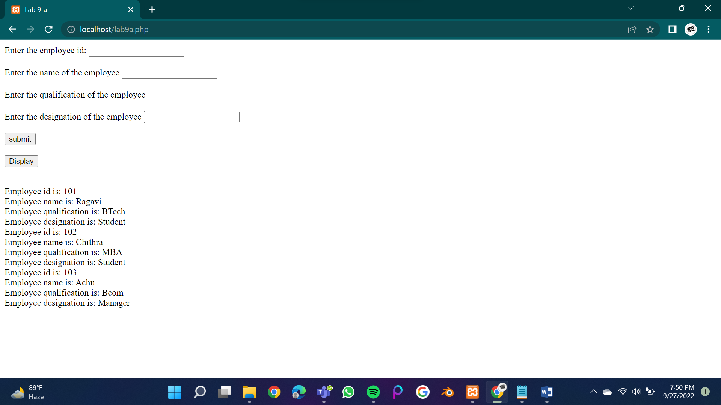

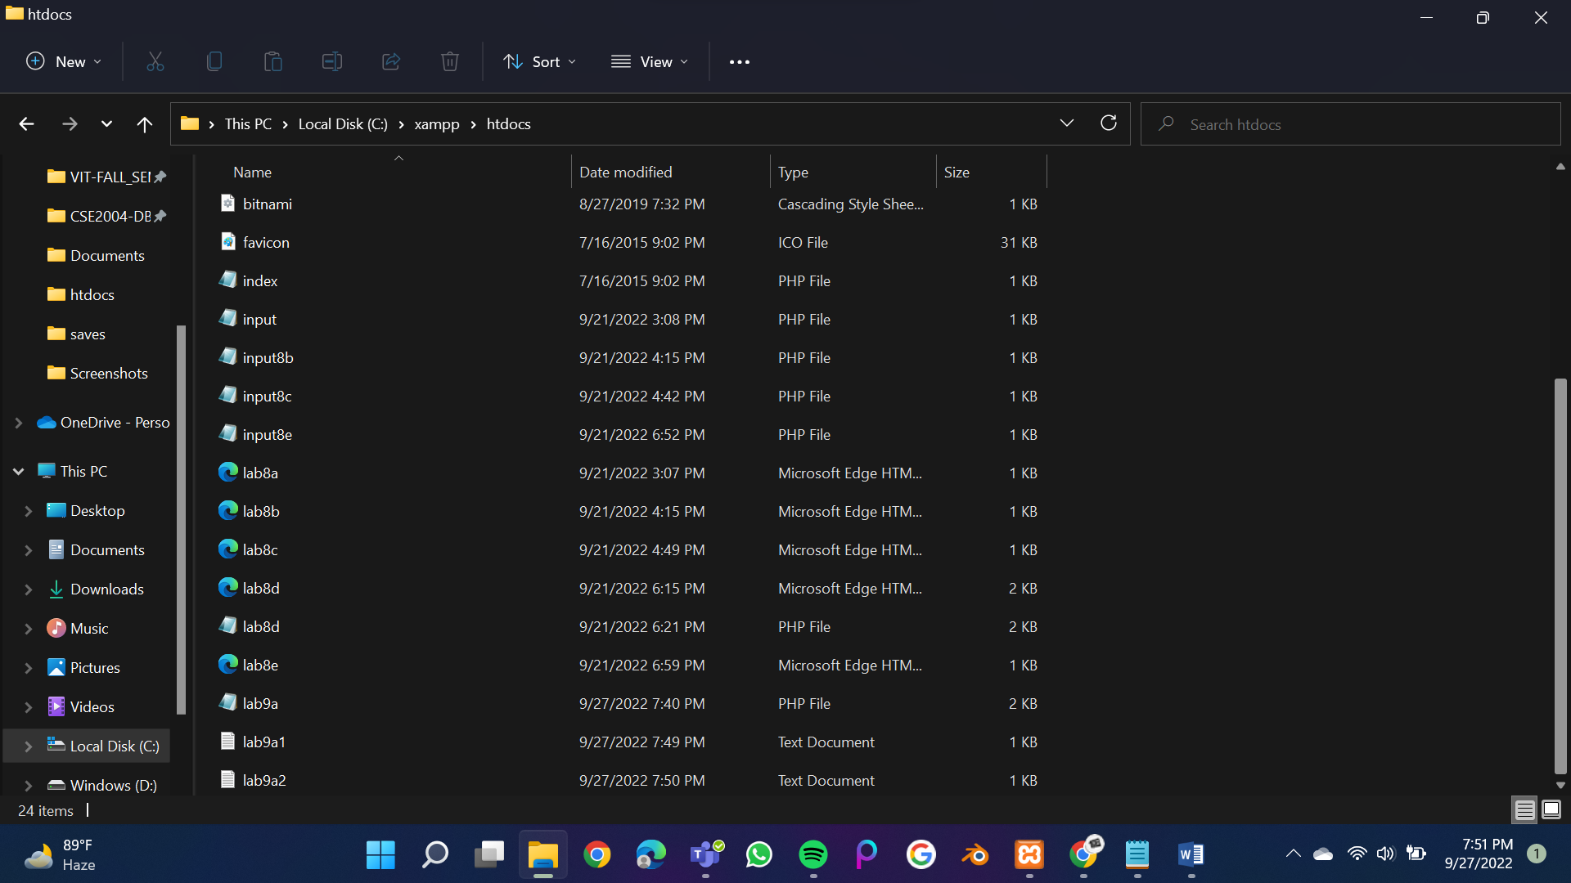

Lab9a1.txt:



Laba2.txt:



**Q2)**

**Code:**

**lab9b.php:**

<html>

<head>

<title>Lab 9 -b</title>

</head>

<body>

<form action="" method="POST">

<label for="acno">Enter the account number :</label>

<input id="acno" name="acno" type="text">

<br><br>

<label for="ini">Enter the initial balance :</label>

<input id="ini" name="ini" type="text">

<br><br>

<label for="tot">Enter the total items charged :</label>

<input id="tot" name="tot" type="text">

<br><br>

<label for="cre">Enter the total credits applied to the customer's account :</label>

<input id="cre" name="cre" type="text">

<br><br>

<input type="submit" value="submit" name="submit">

</form>

<form action="upload.php" method="post" enctype="multipart/form-data">

Select file to upload:

<input type="file" name="fileToUpload" id="fileToUpload">

<input type="submit" value="Upload File" name="submit">

</form>

<?php

if(isset($_POST['submit'])){

$acno=$_POST['acno'];

$ini=$_POST['ini'];

$tot=$_POST['tot'];

$cre=$_POST['cre'];

$res=$tot+0.3*$tot+$cre+$cre*0.2;

$b=sqrt($ini);

$bonus=$res-$b;

$handle=fopen('./lab9b1.txt','a+');

$b="\nInitial balance is: ".$ini;

$a="\nAccount number of the customer is: ".$acno;

$c="\nTotal items charged by the customer is: ".$tot;

$d="\nTotal credits applied to the customer's account is: ".$cre;

$e="\nBonus points: ".$bonus;

fwrite($handle,$a);

fwrite($handle,$b);

fwrite($handle,$c);

fwrite($handle,$d);

fwrite($handle,$e);

fclose($handle);

$handle1=fopen('lab9b1.txt','r');

while(!feof($handle1))

{

echo(fgets($handle1,1024));

echo('<br/>');

}

fclose($handle1);

}

?>

</body>

</html>

**upload.php:**

<?php

$target_dir = "uploads/";

$target_file = $target_dir . basename($_FILES["fileToUpload"]["name"]);

$uploadOk = 1;

$FileType = strtolower(pathinfo($target_file,PATHINFO_EXTENSION));

if(isset($_POST["submit"])) {

$check = filesize($_FILES["fileToUpload"]["tmp_name"]);

if($check !== false) {

//echo "File is of the format - " .mime_content_type('name'). ".";

$uploadOk = 1;

} else {

echo "The file is not of the required format";

$uploadOk = 0;

}

}

if (file_exists($target_file)) {

echo "Sorry, file already exists.";

$uploadOk = 0;

}

if ($_FILES["fileToUpload"]["size"] > 500000) {

echo "Sorry, your file is too large.";

$uploadOk = 0;

}

if($FileType != "pdf" && $FileType != "txt" && $FileType != "php") {

echo "Sorry, only PDF ,TEXT and PHP files are allowed.";

$uploadOk = 0;

}

if ($uploadOk == 0) {

echo "Sorry, your file was not uploaded.";

} else {

if (move_uploaded_file($_FILES["fileToUpload"]["tmp_name"], $target_file)) {

echo "The file ". htmlspecialchars( basename( $_FILES["fileToUpload"]["name"])). " has been uploaded.";

} else {

echo "Sorry, there was an error uploading your file.";

}

}

?>

**Output:**

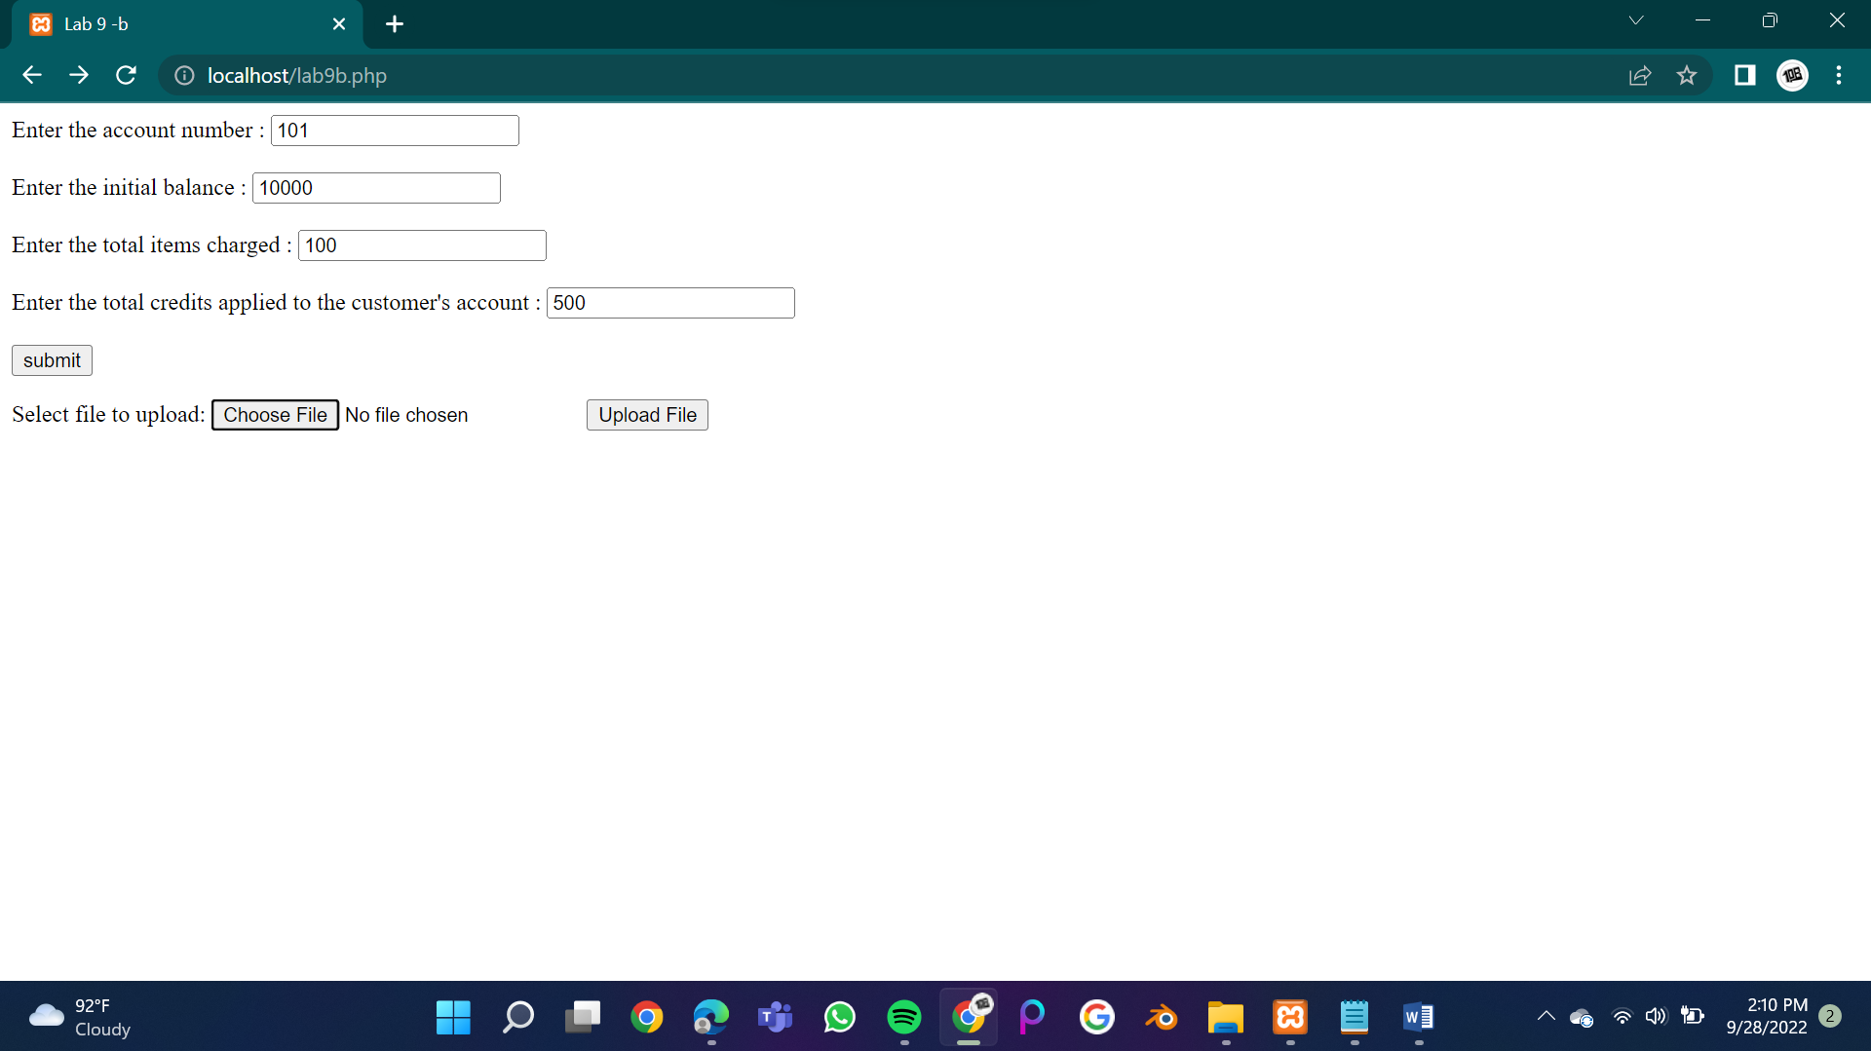

After submitting:

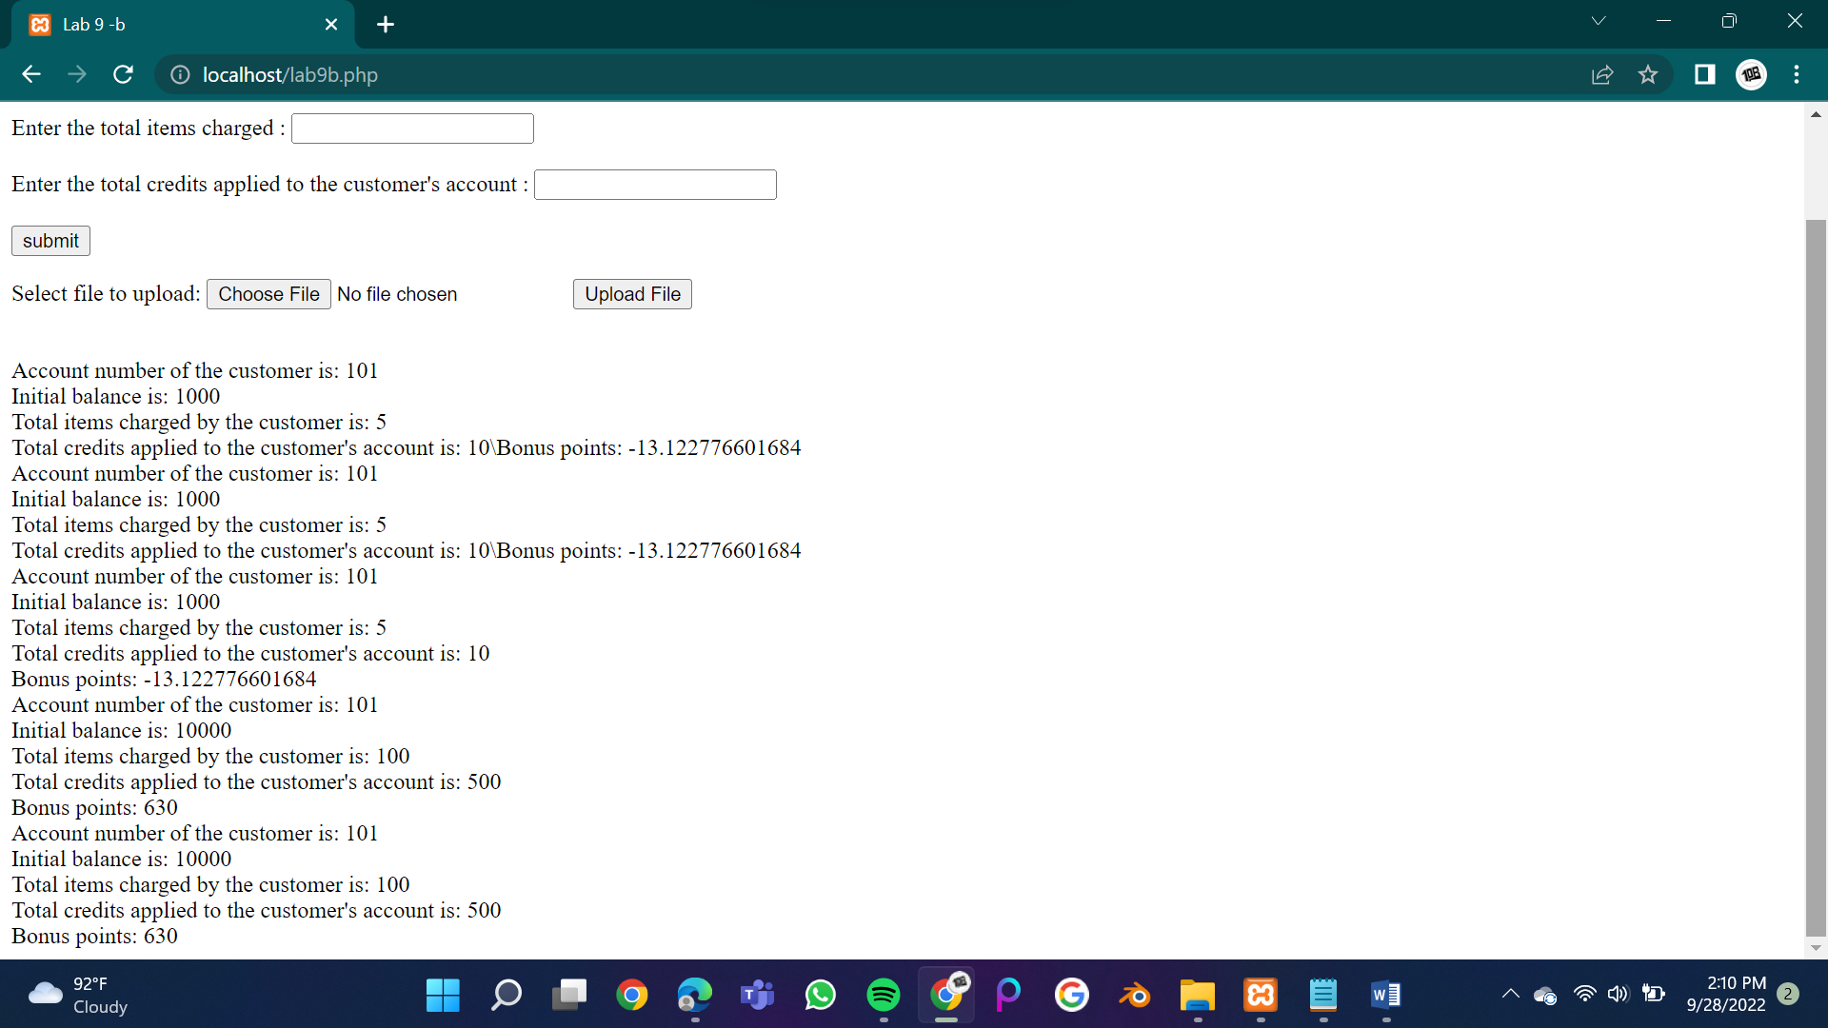

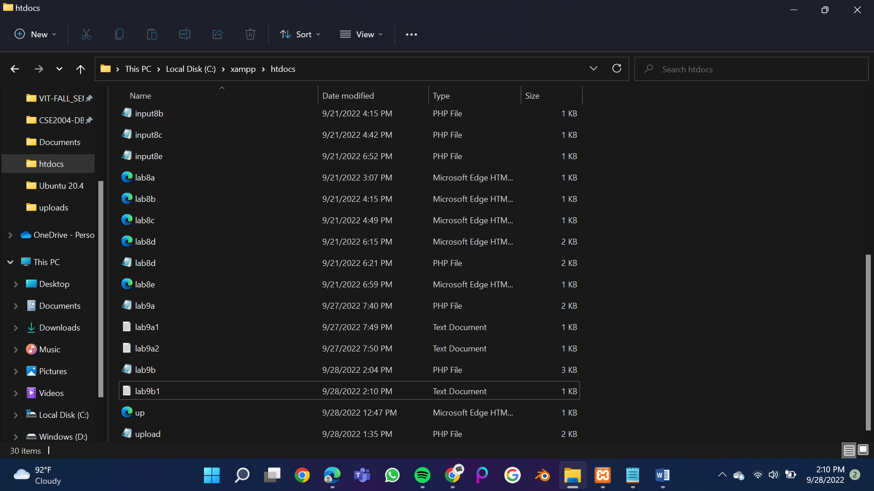

Lab9b1.txt:

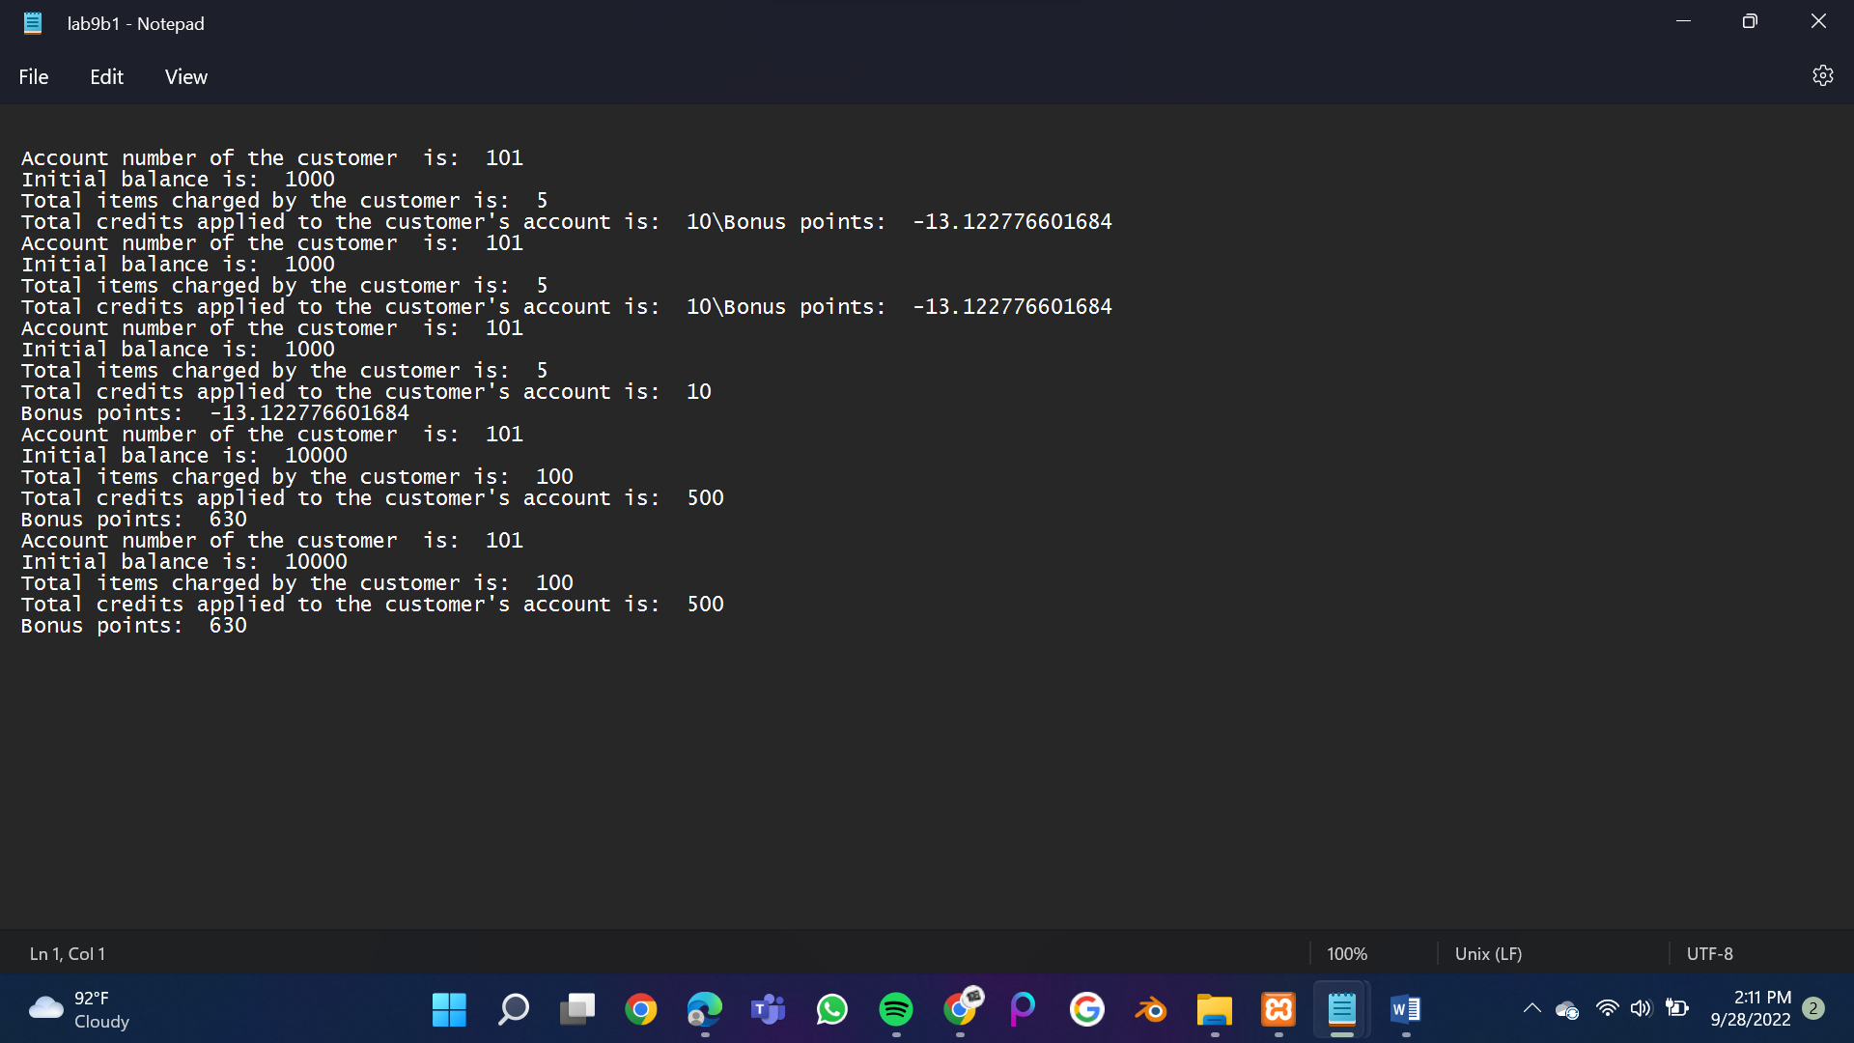

Uploads folder in xampp/htdocs:

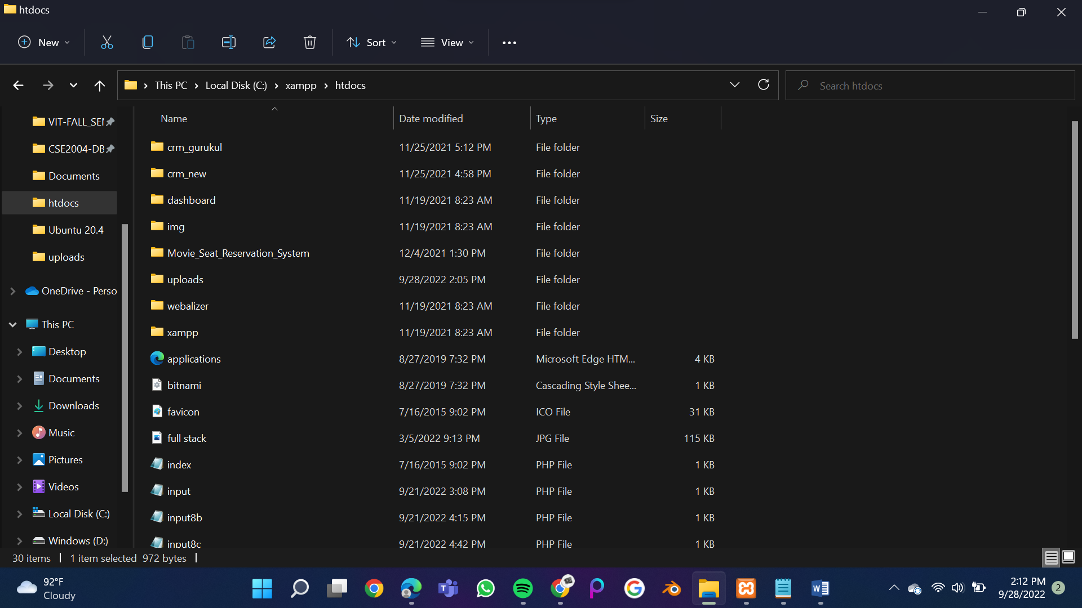

To choose file:

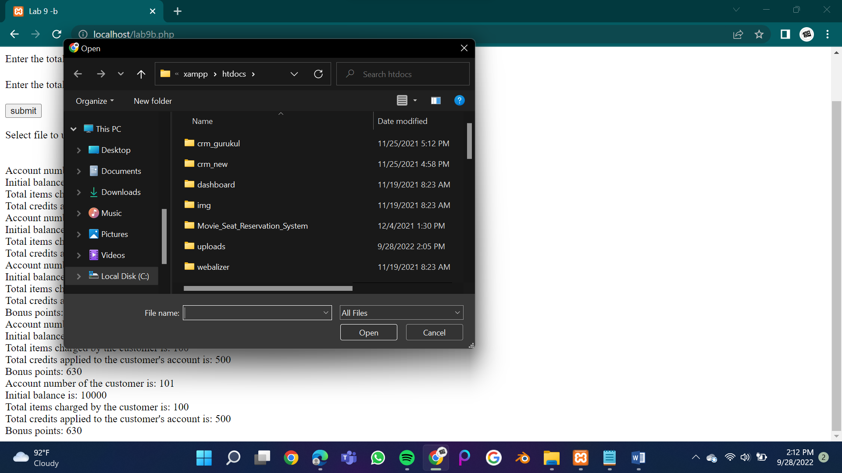

After choosing:

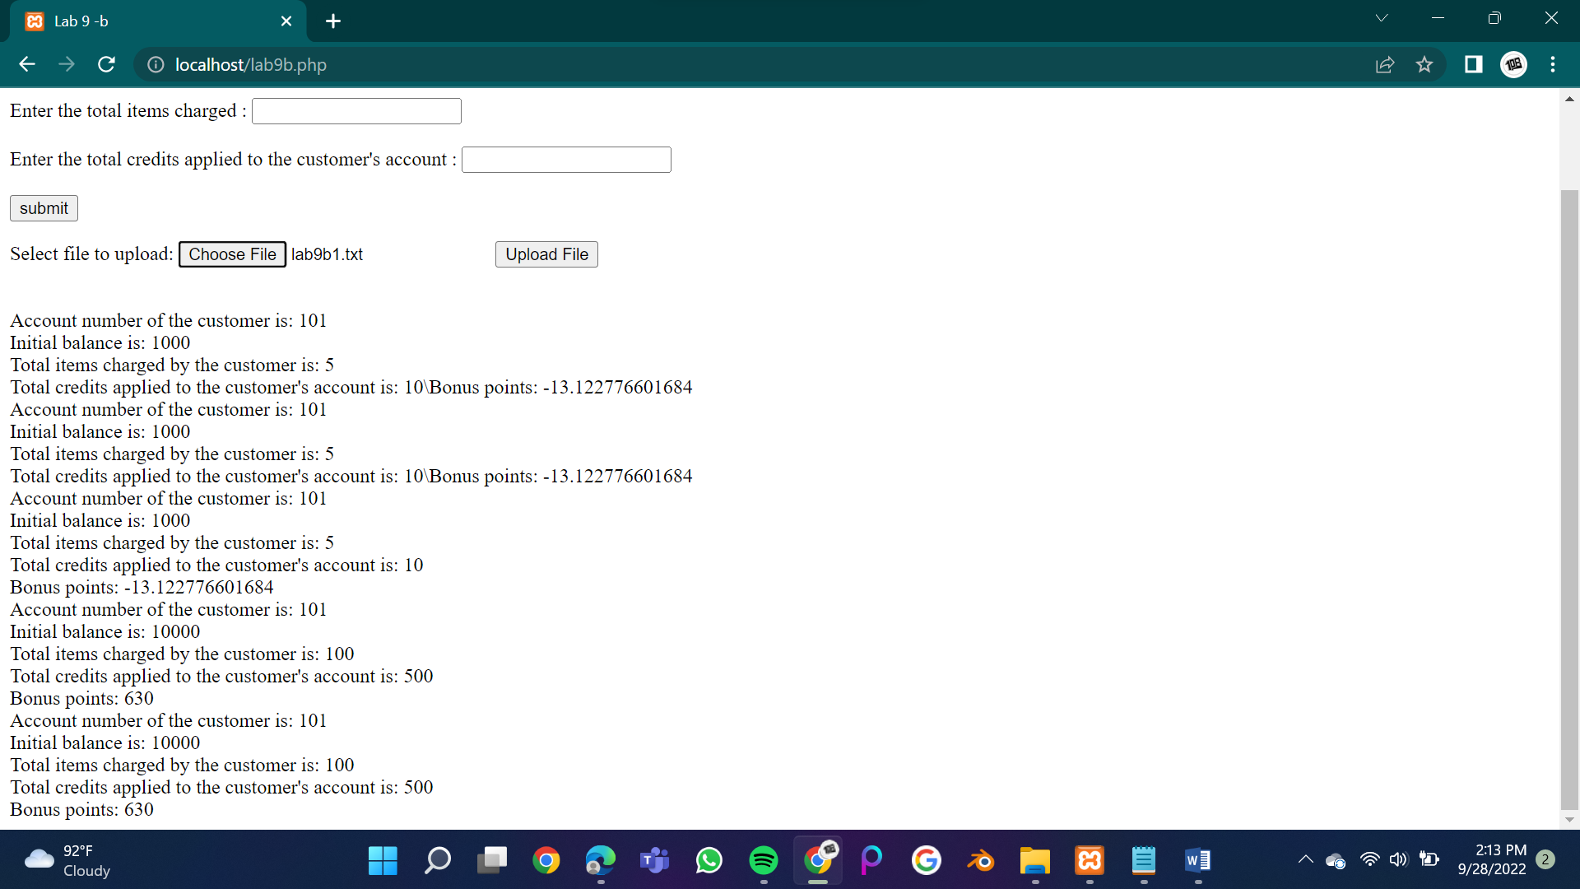

After clicking onto upload:



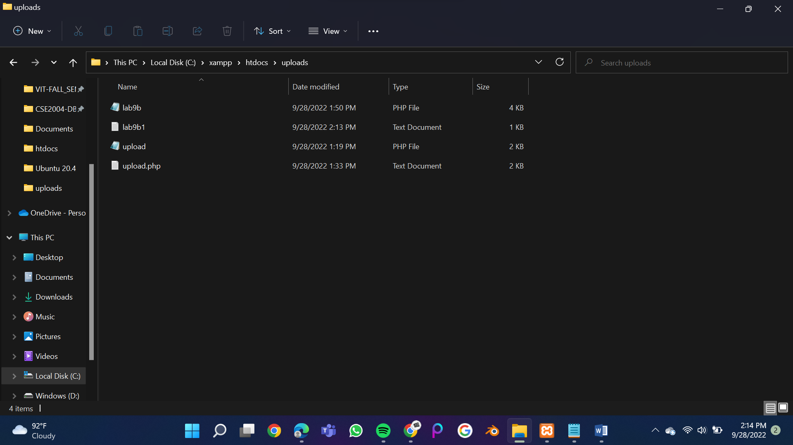

The code will not other file types except for pdf,txt,php files

